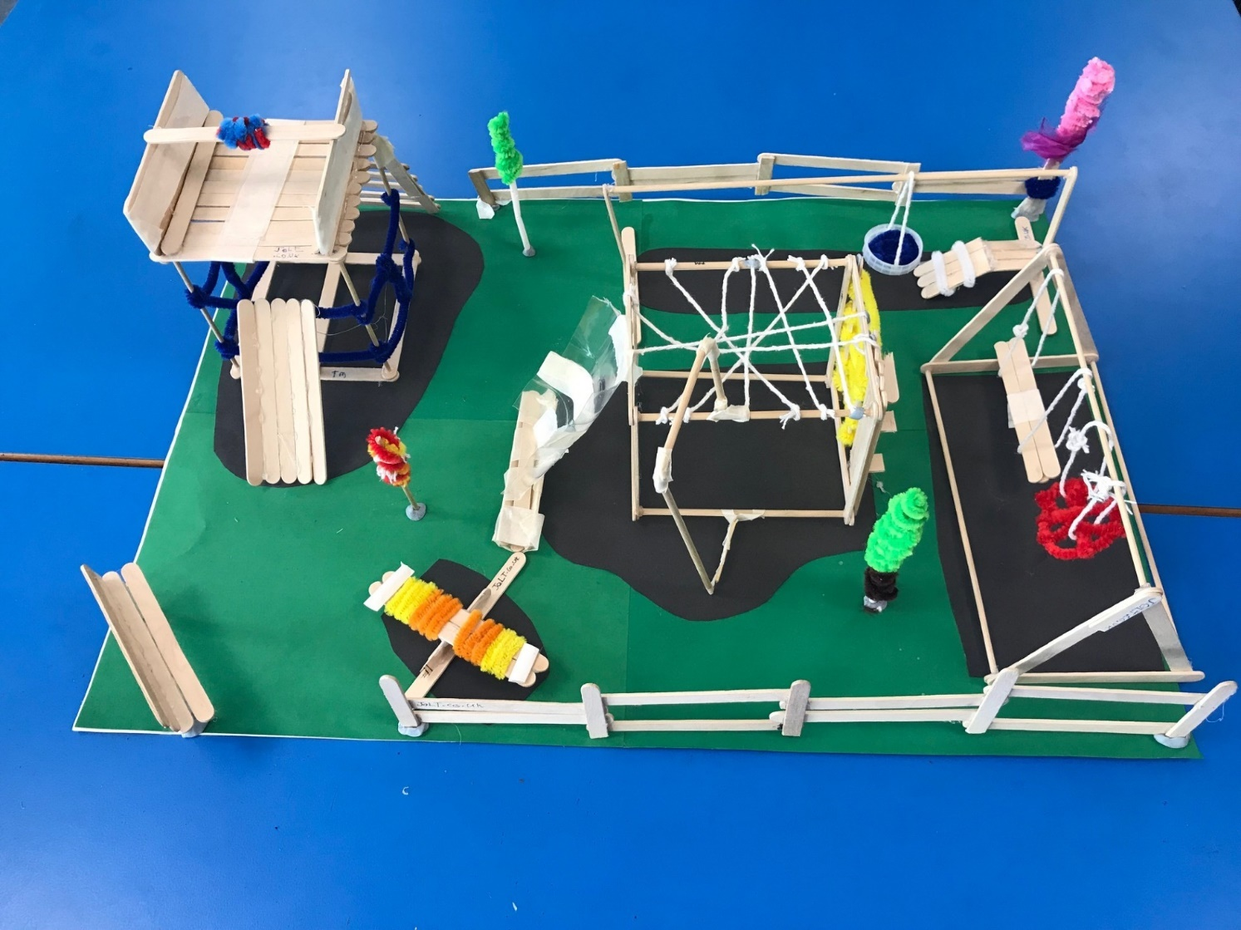

JOLT

It was fun making the playground. Even though it was hard, we kept on going and built a nice, calm playground for a fun time. We tested our building strength, and it stood up well.

We made fences for the park with lolly sticks, blue tac and a glue gun.

Our part has a bench for anyone who want to visit and sit down.

Jacob, Oliver, Levi and Tommy

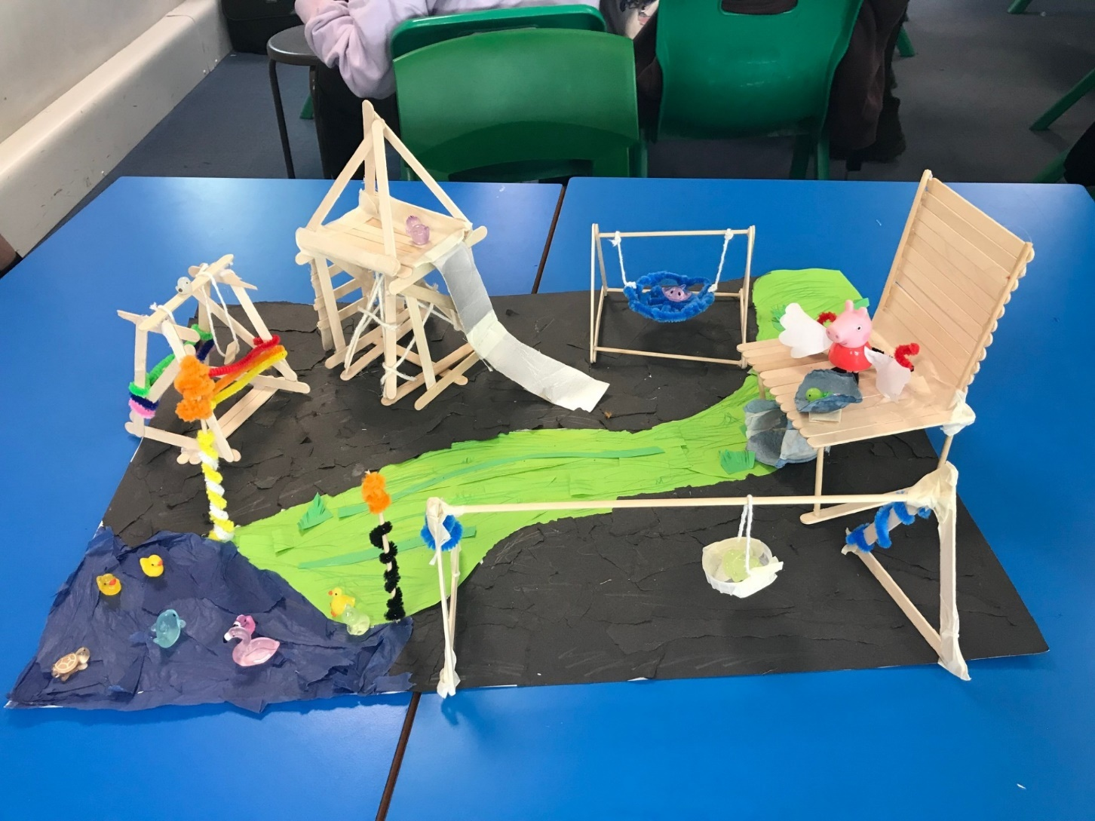

Our Park Playground Experience

It was fun making the playground because we were given creative freedom with our materials.

It tested out skills, and we felt proud of that we were able to construct our fully build park.

Laila, Daphne, Jessie, Eve and Molly

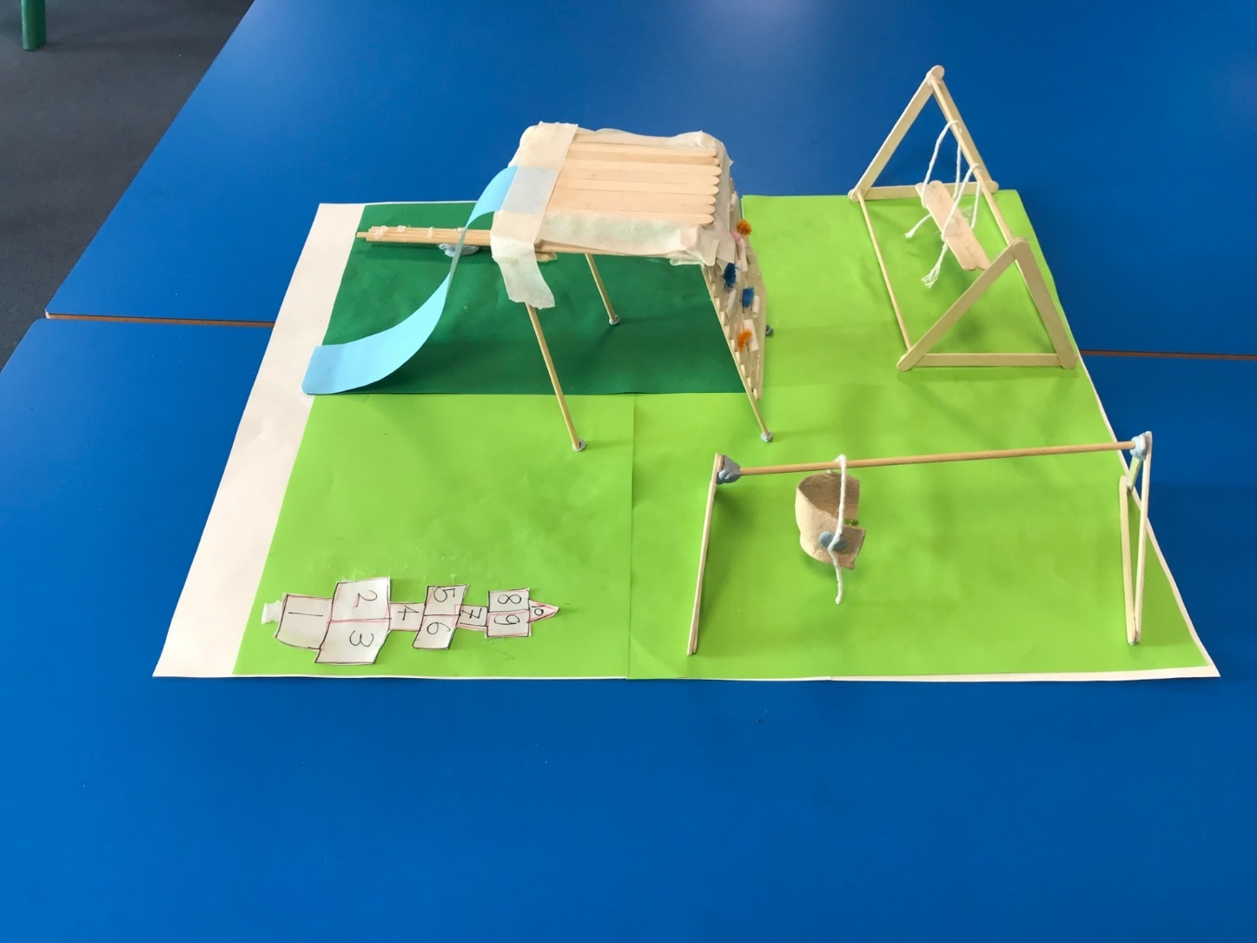

We made a park. It was fun slowly watching it piece together like a puzzle. Although we didn’t build very much, it was still fun and pushed out creativity to its limits. We have a rock wall with little bits of pipe cleaner. We also have a working swing and blue slide.

Jenson, Emilis, Oscar and Davonte

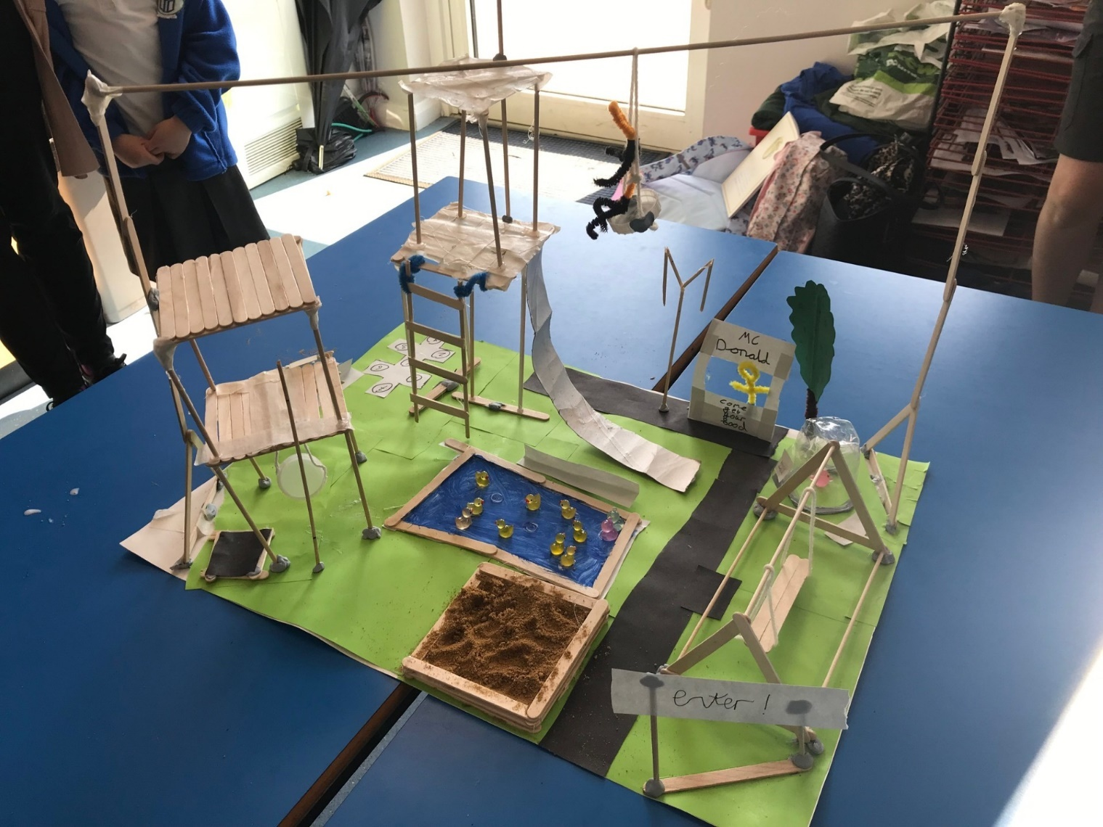

Thriller Park

As you enter the amazing, joyous and magnificent Thriller Park you will notice two 5-foot watch towers. One with a slide and one with a pole. You will also notice a nice sparking pond with ducks and some frogs. Our trademark is a 10-foot high zipline, which is only for the daredevils. Once you have had enough you can have a MacDonalds to finish.

It’s been great building our park.

Jack, Joey, Daniel and Leo

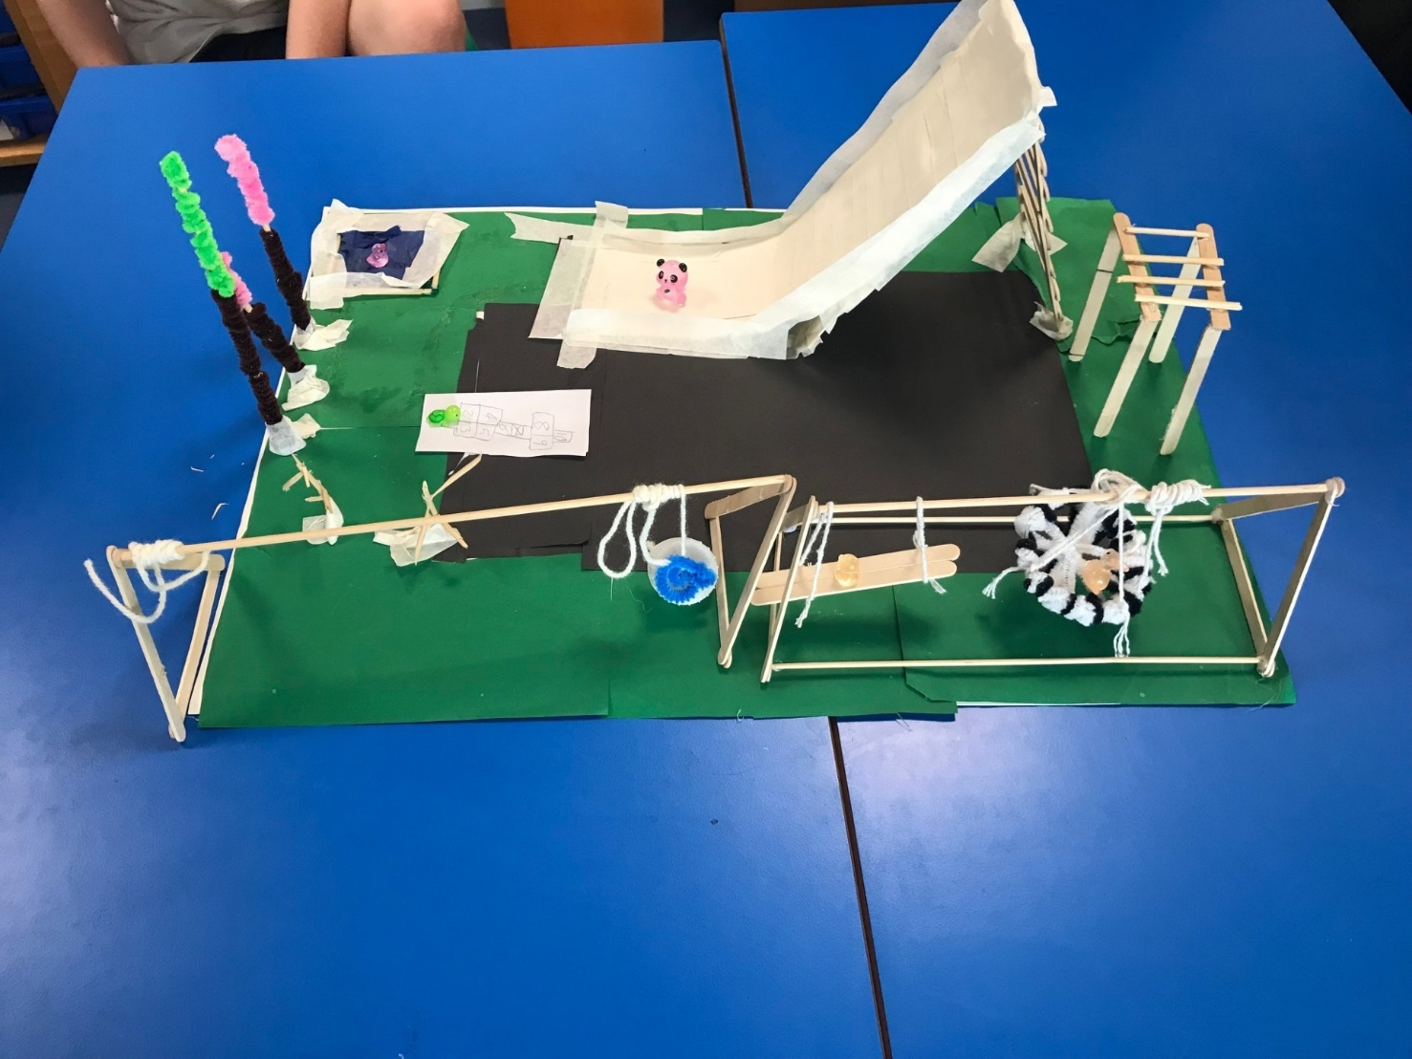

Our experience was a full rollercoaster. At the start all we managed to do was one swing (we nearly gave up). Then, on the last days of working, we persevered and worked hard to build a slide, zipline, pond, trees, monkey bars and hopscotch.

Lucas, Eli, Zand, Cristovao and Mario.

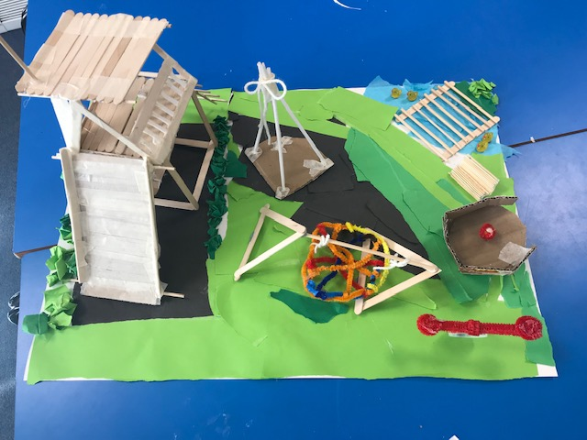

Making this playground was so much fun! Our group loved and enjoyed making it using different materials. Using different things to create one thing was interesting and challenging. Let’s say we love it!

Emily, Ethan, Ruby, Victoria and Holly

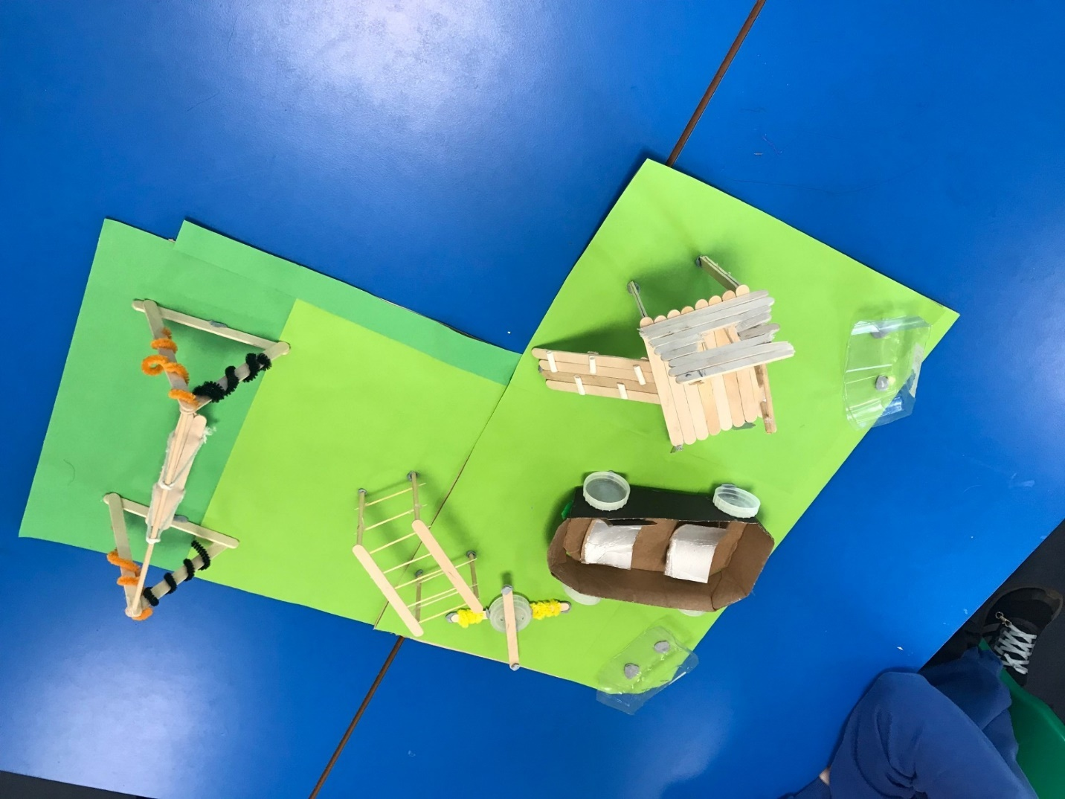

Jessica, Jonathon, Matthew and Rupert